Rolling Shutter
Installation Electric

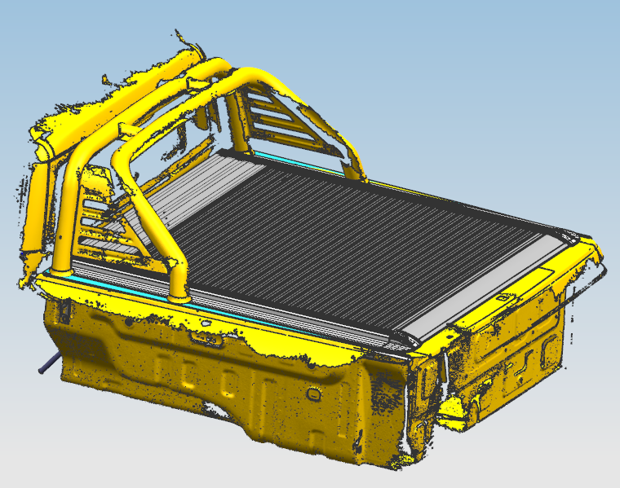
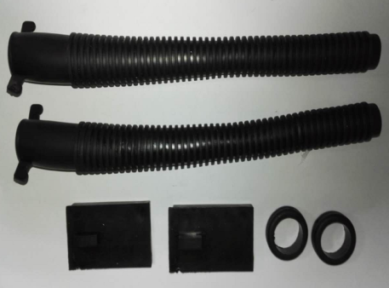
Notice Before Installation
◆The following data is for reference only and may differ from the actual product you received,
but they are assembled in the same way.
◆Please read the instructions thoroughly for installation, which will also help you avoid scratches
or other potential damage to your attractive car.

Parts List

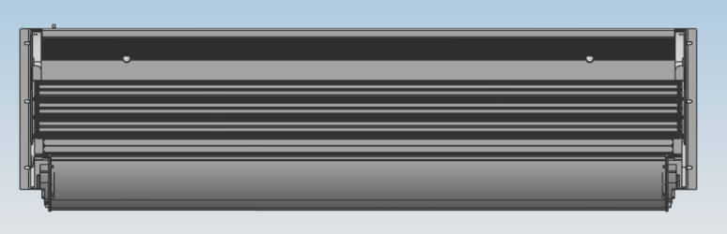  Chassis and roller shutter  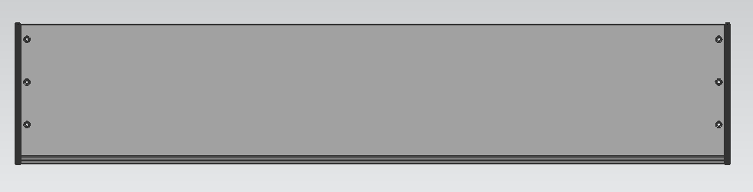  Aluminum cover plate | 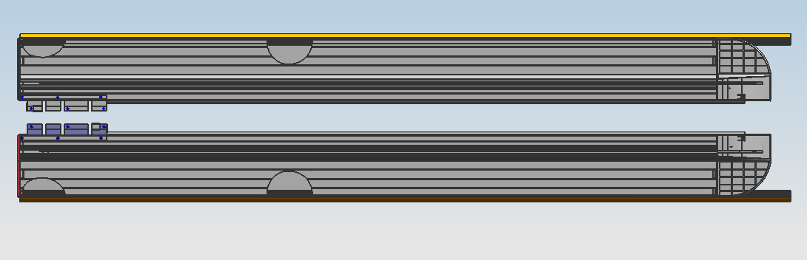2223  Side groove frame (left and right)  3212312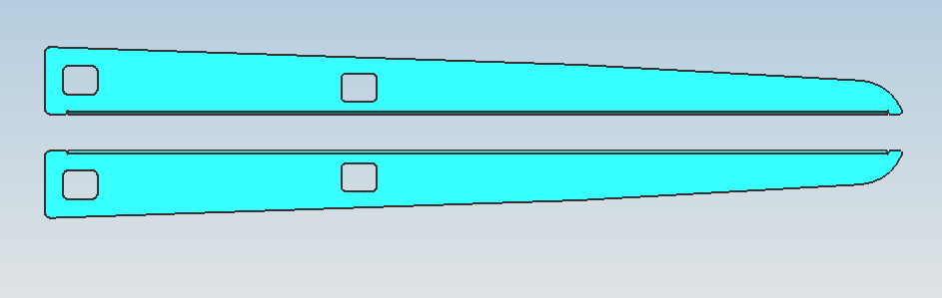3  Mounting slot bracket (left and right)
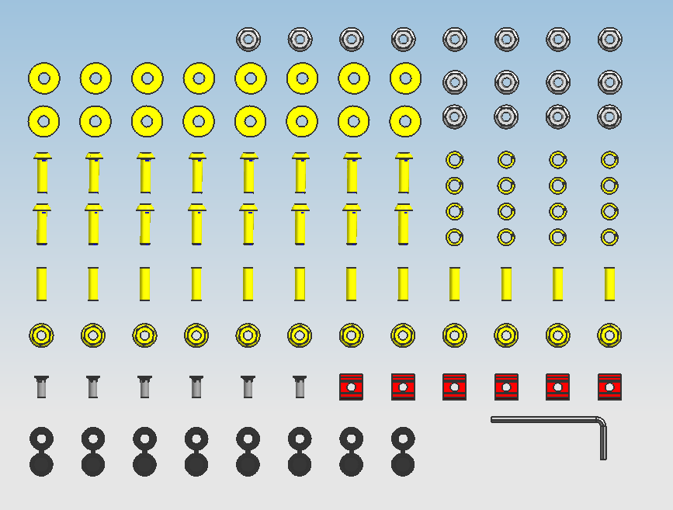  Accessory kit | 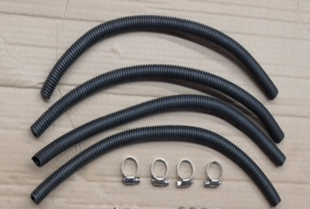  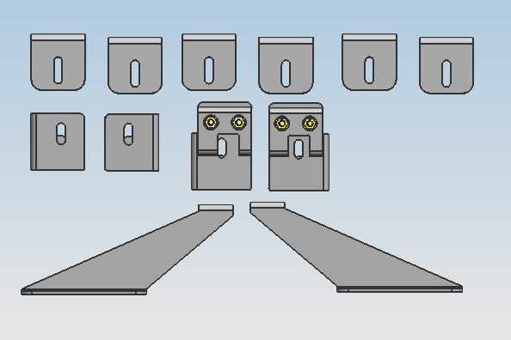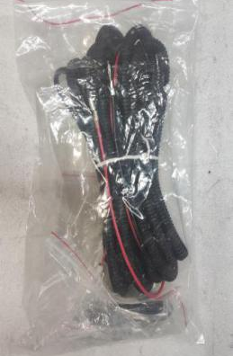  Wire harness package  Drainage pipes, and clamps

Installation Steps
Secure the channel frame with screws and hex flange nuts (do not tighten completely; leave some slack for adjusting the cover plate).
1.Assembling roller lid
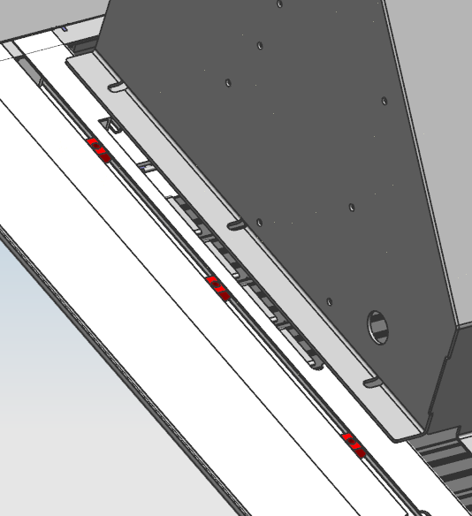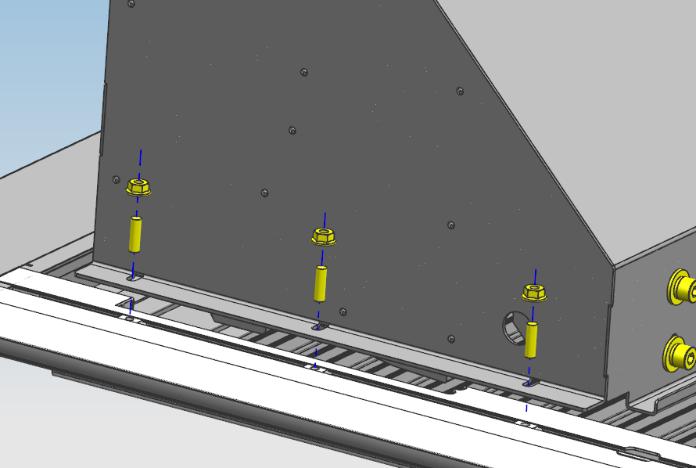
Assemble small blocks into corresponding holes
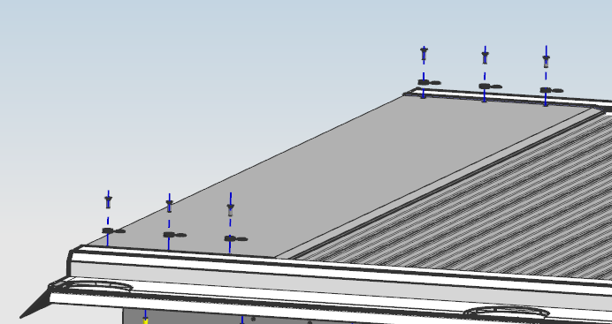
Secure the cover plate with cross-slotted countersunk screws and M5 screw caps, then secure the slot frame.

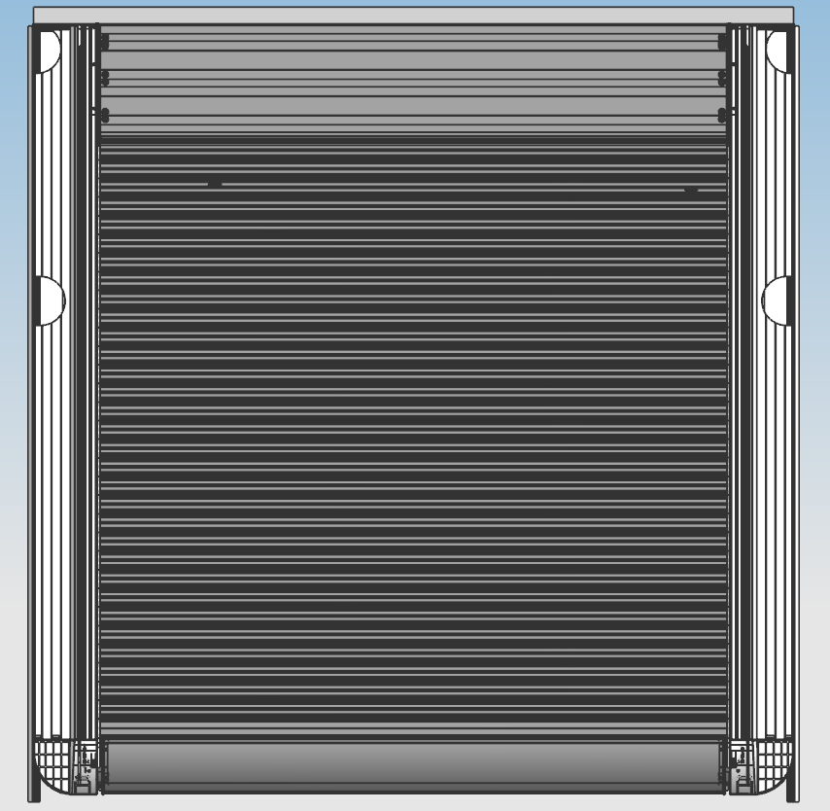
As shown in the figure, the assembled appearance (note that the left and right spacing should be consistent).

2.Install the loading bracket
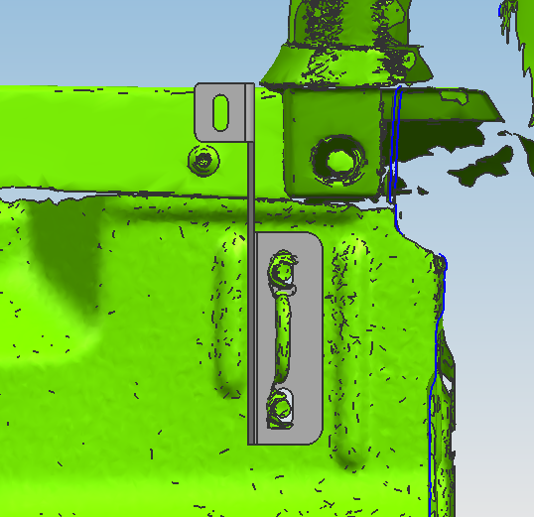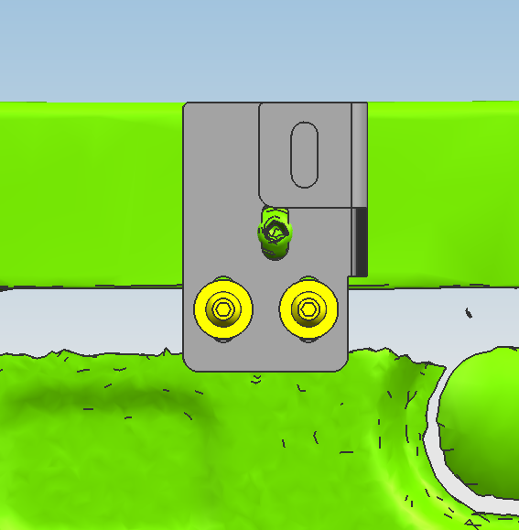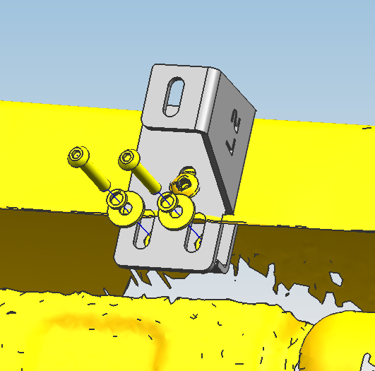
Bracket 2 (left) should be positioned as shown in the figure and secured using the original vehicle screws. Then, use black zinc-plated M6*35 hexagon socket head cap screws (45#) and nuts to secure it (do not tighten completely; leave some room for adjustment). Ensure symmetry on both sides.
Bracket 1 (left), as shown in the figure, is secured using the original vehicle screws (do not tighten completely; leave some room for adjustment). It is symmetrical on both sides. This part is for the left side.

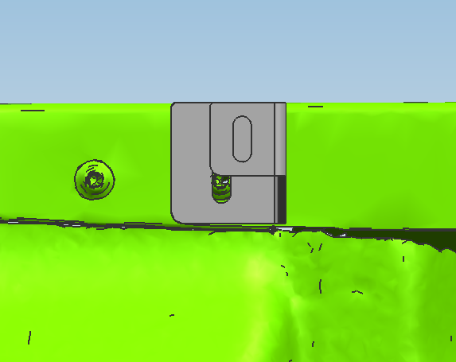
Bracket 3 (left), as shown in the figure, is secured with the original vehicle screws (do not tighten completely; leave some room for adjustment). Ensure symmetry on both sides.
3.Install the Side groove frame (note: remove the roll bar first before installation)
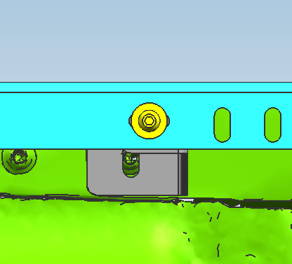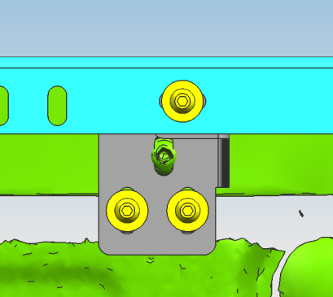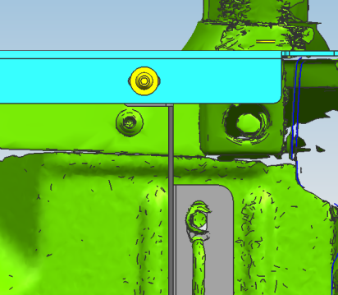
Bracket 3
Bracket 2
Bracket 1
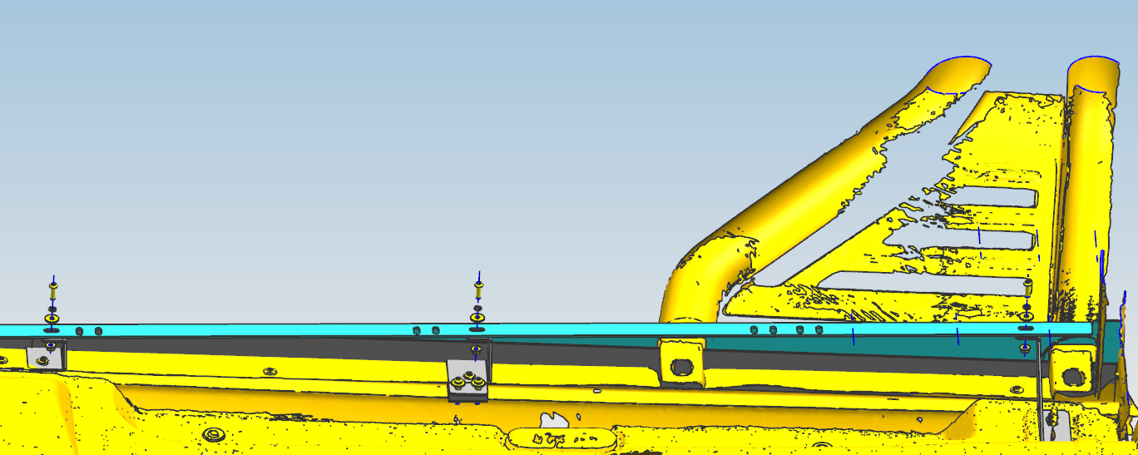
Install the Side groove frame as shown in the figure. Use M6*20 black zinc-plated hexagon socket head cap screws (45#) with M6 nuts to secure it (the installation is the same on both sides). After the Side groove frame is level, tighten the brackets installed at the front.

4.Installation the wire harness
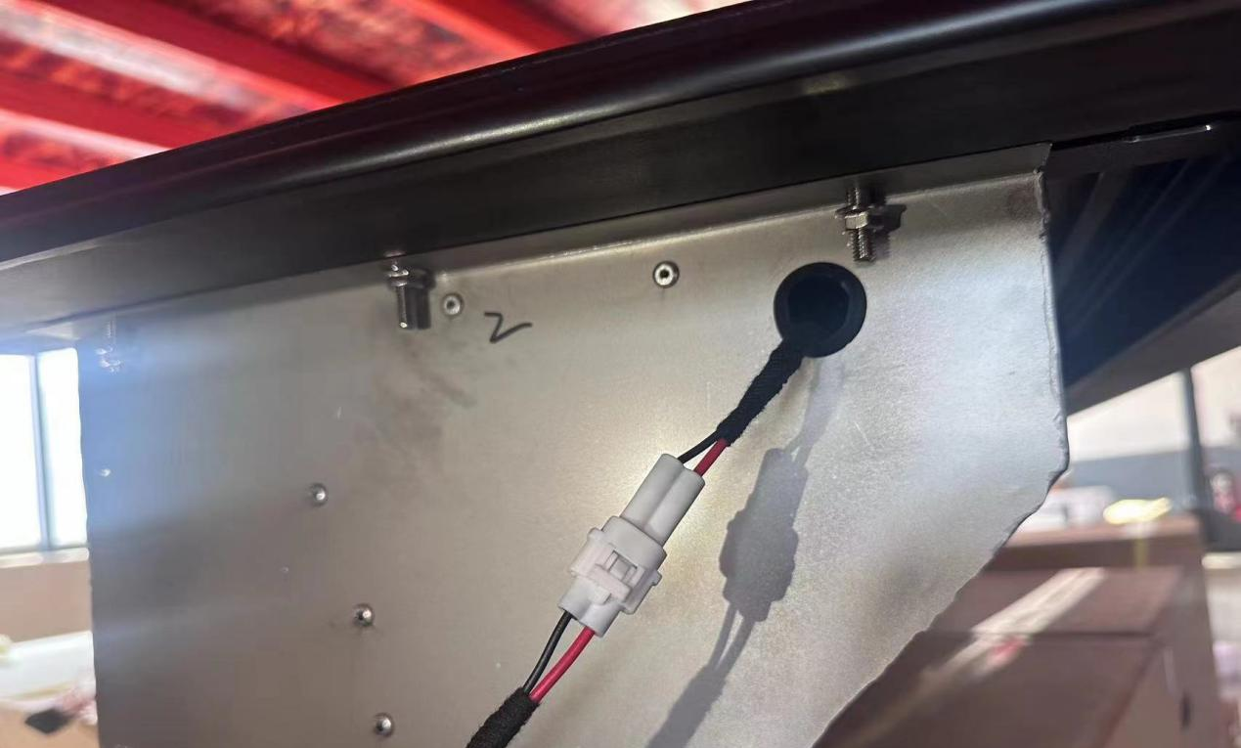
Connect the wiring harness of the wiring harness package to the main control wire.
5.Place the assembled electric roller shutter close to the inner side of the vehicle compartment. Use a tape measure to measure the front-to-back spacing of the left and right channel frames to ensure that the roller shutter is positioned in the center of the vehicle compartment. The spacing must be consistent.
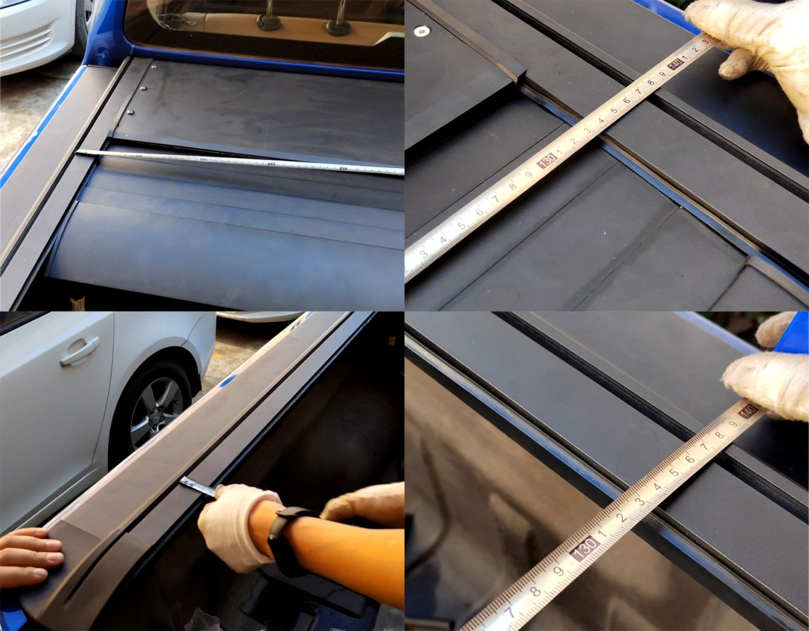
Consistent
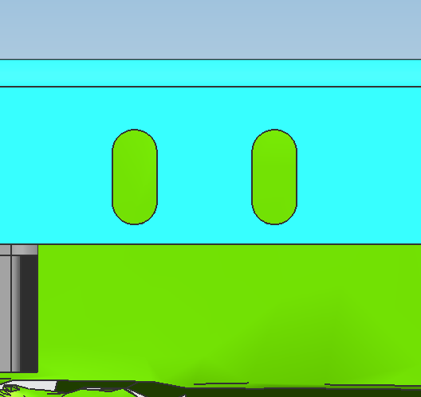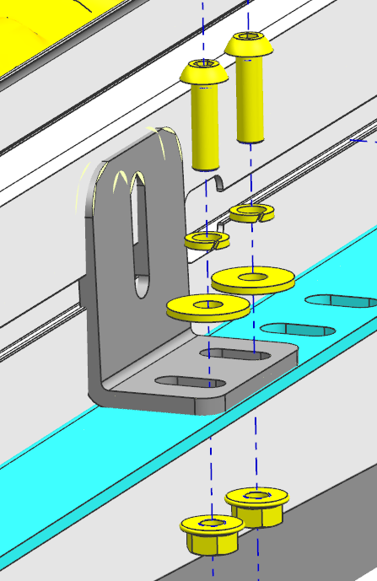
Install the side groove frame bracket as shown in the figure. Use M6*20 black zinc-plated hexagon socket head cap screws (45#) with M6 nuts to secure it (install the same on both sides). (Do not tighten completely; leave some room for adjustment.)
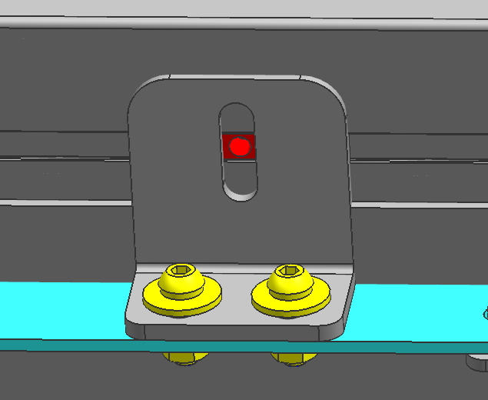
Move the small blocks to their corresponding positions.
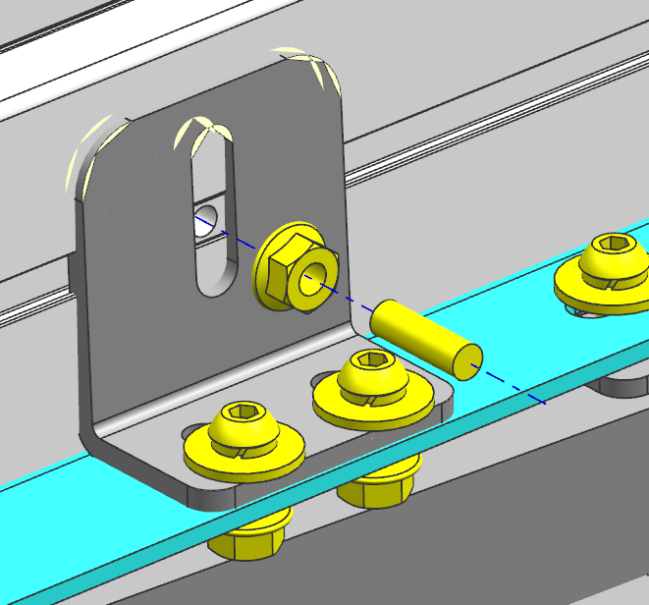
Secure with screw and nut
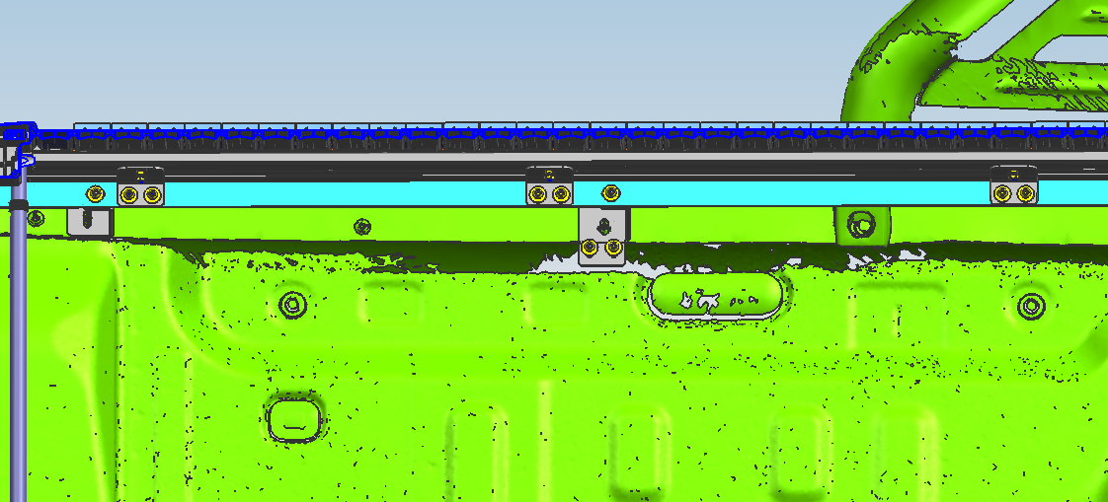
Install the same on both sides.

6.Adjust the electric roller shutter to a horizontal position (some models have corresponding accessories for adjustment) (it must be adjusted to a horizontal position, otherwise it will affect the usage effect).
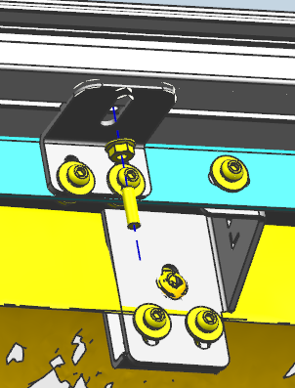
Adjust to horizontal position
7.Guide the drain-pipe to the outside of the car.
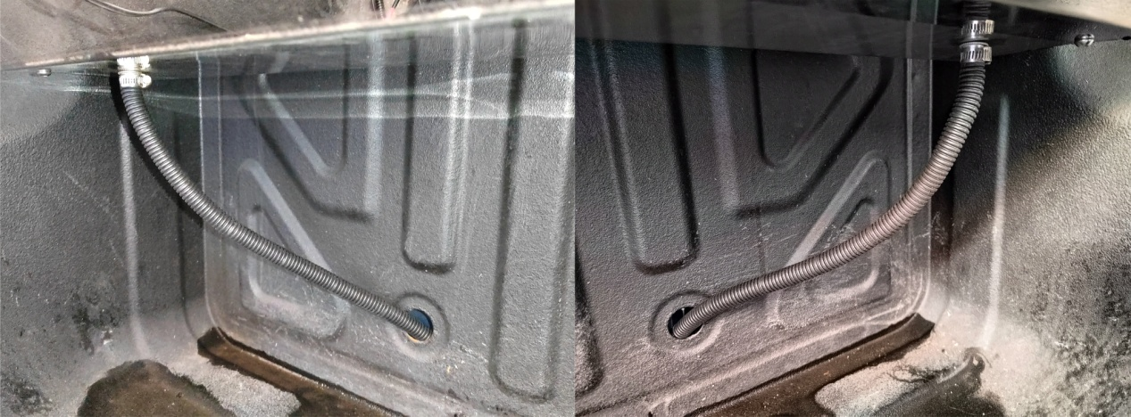
Drain-pipe goes down from this hole
Drain-pipe goes down from this hole

8.Wire harness layout (secure with zip ties at appropriate intervals to the original vehicle)
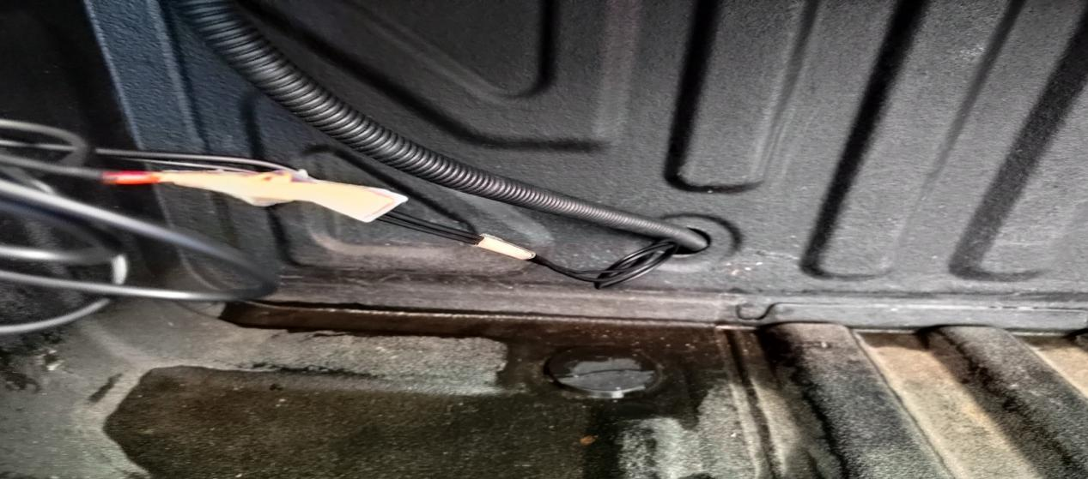
Drain-pipe goes down from this hole
去
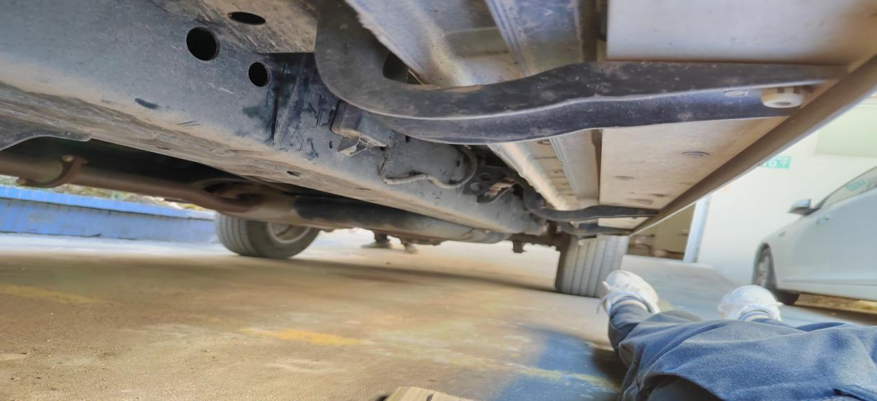
Thread along the chassis beam to the engine battery

9.Open the hood, locate the battery ground wire (negative) and power wire (positive) (connect the ground wire first, then the power wire, as shown in the figure below, and connect the ground wire (black wire) properly).
第三步，接电源线/正值（红色线）（注意：需先拔保险丝，再接电源线）
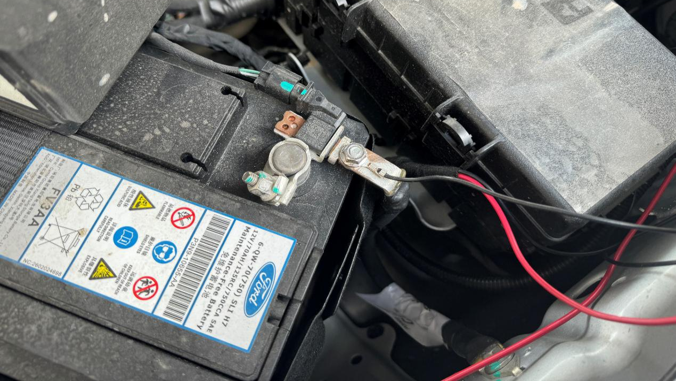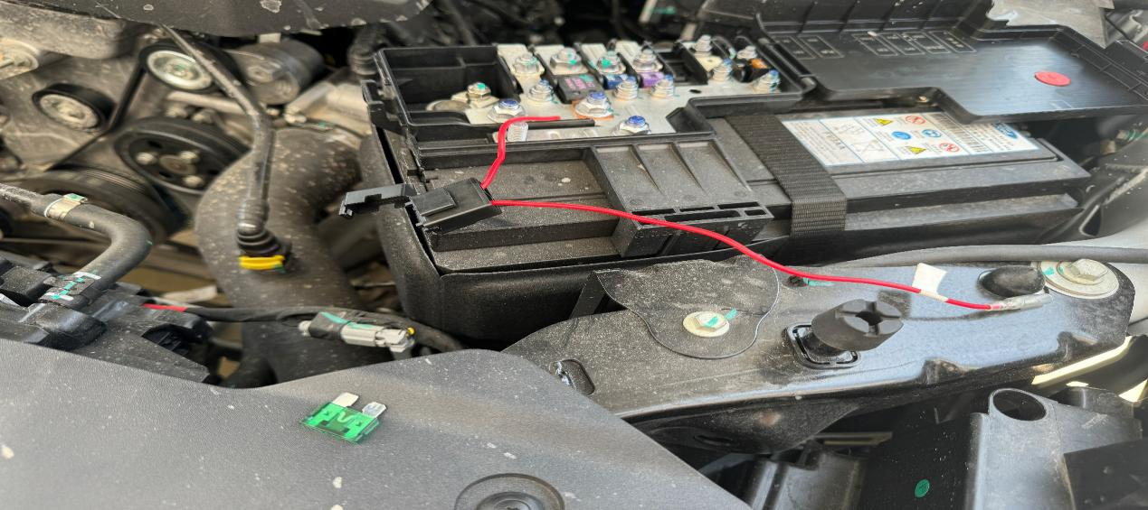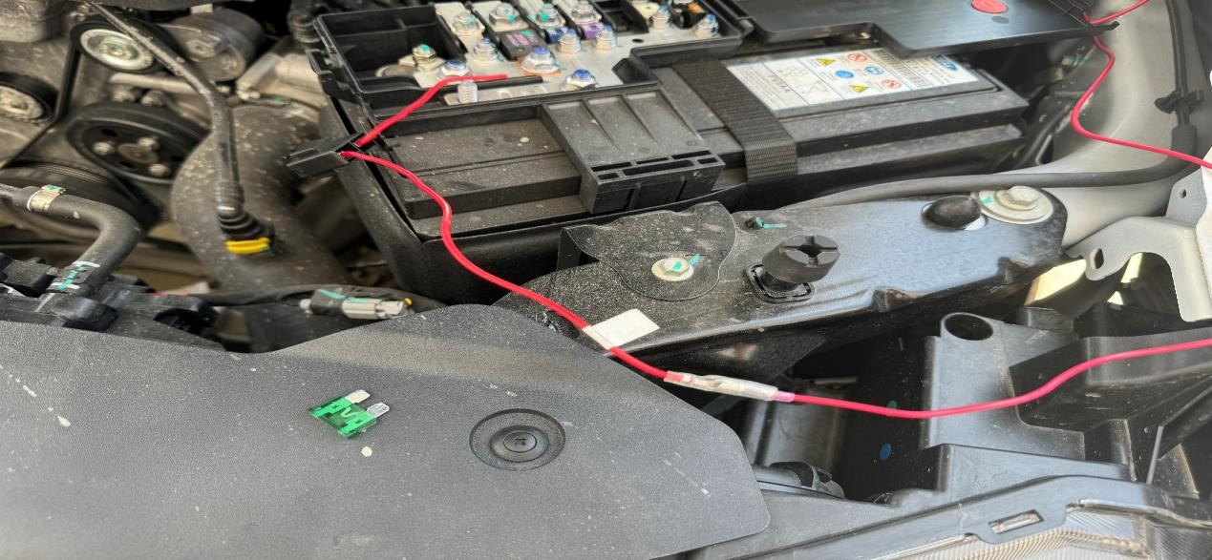
Step 1: Ground wire/negative terminal (black wire)
第二步，拔保险丝
Step 4: Connect the fuse power cord to the ECU power cord (note: the fuse is still in the removed state).
Step 3: Connect the power cord/positive terminal (red wire) (Note: Remove the fuse first, then connect the power cord).
Step 2: Pull out the fuse.
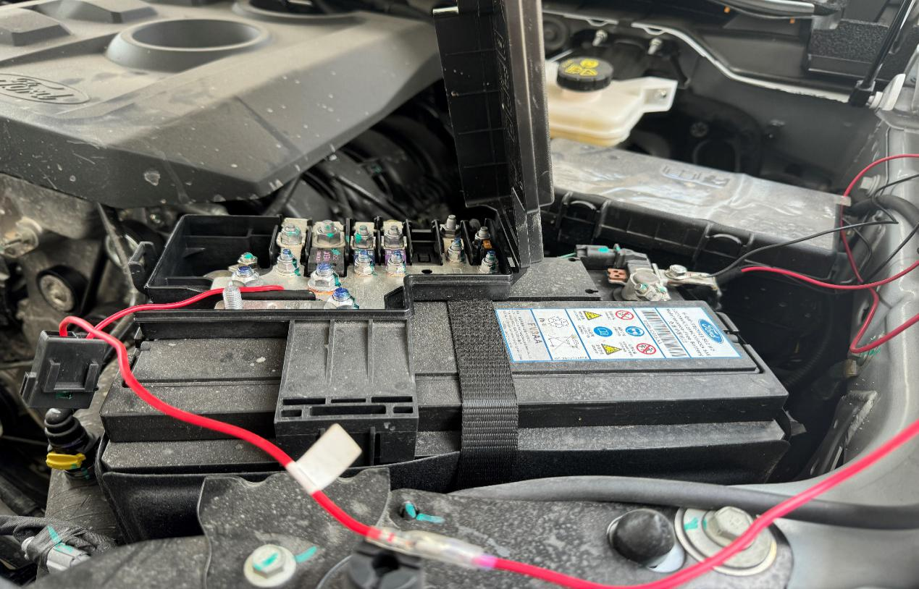
Step 5: Reinsert the fuse.
10. Remotely control the electric roller shutter switch several times. If there are no abnormalities, the installation is complete (note: electric roller shutters have a smart learning process; during initial installation, the switch must be operated several times to activate the end buffer and anti-pinch functions).
Function Description of Electric Roller
- The electric roller shutter has an intelligent learning function,which automatically learns to recognize its movement range after initial installation and power outage restart
- The electric roller shutter has intelligent anti pinch function.When there is an obstacle blocking the operation of the electric roller shutter,the anti pinch function will be triggered when the electric roller shutter is subjected to a certain force
3.When opening the electric roller shutter, the LED light will automatically light up and go out after 60 seconds; When closing the electric roller shutter, the LED light will automatically turn off
Instructions for Using Electric Roller
1.Press the remote control opening button to open the electric roller shutter.During the operation of the electric roller shutter,pressing any remote control button can stop it at any time;When the electric roller shutter is in any position (not the starting position),pressing the corresponding remote control button can 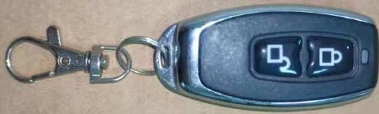
2.Press the remote control close button to close the electric roller shutter.During the operation of the electric roller shutter,pressing any remote control button can stop it at any time;When the roller shutter is in any position (not the starting position),pressing the corresponding remote control button can perform the corresponding operation.
Exception Handling and Precautions
If it is determined that the motor problem is causing the electric roller shutter to be unusable during later use, the following screws can be loosened to lower the motor, and then the curtain can be temporarily manually opened and closed, waiting for the motor to be replaced.
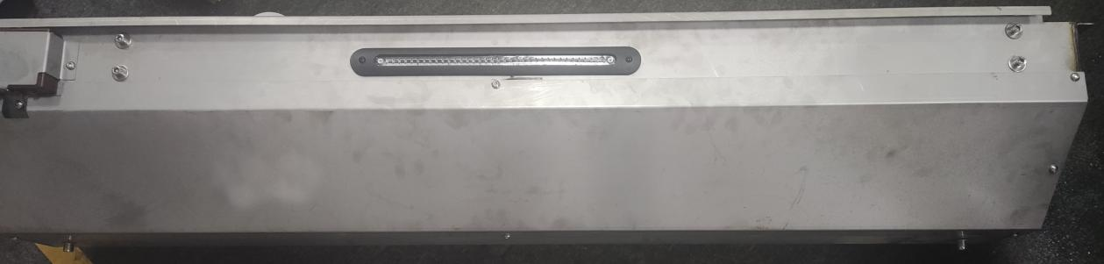
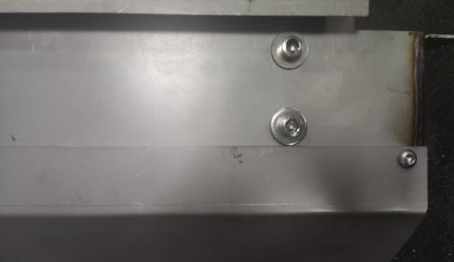
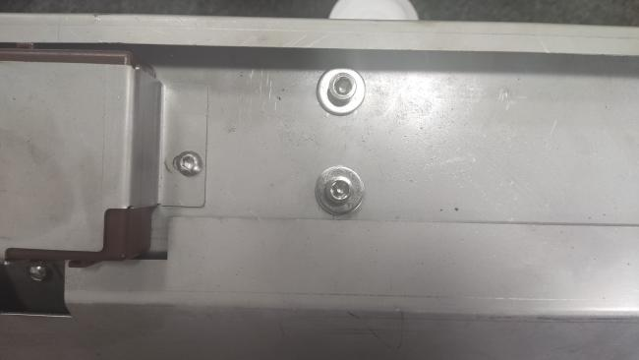
When the electric roller is not fully opened or closed,first check if the battery is running low,then check if there are foreign objects blocking the side rails and box.Finally,apply lubricating grease to the side rails,and open the AL. cover plate to apply lubricating grease to the spiral groove on the inside of the box.Run the electric roller shutter back and forth several times to ensure sufficient lubrication,and solve the abnormal problem.
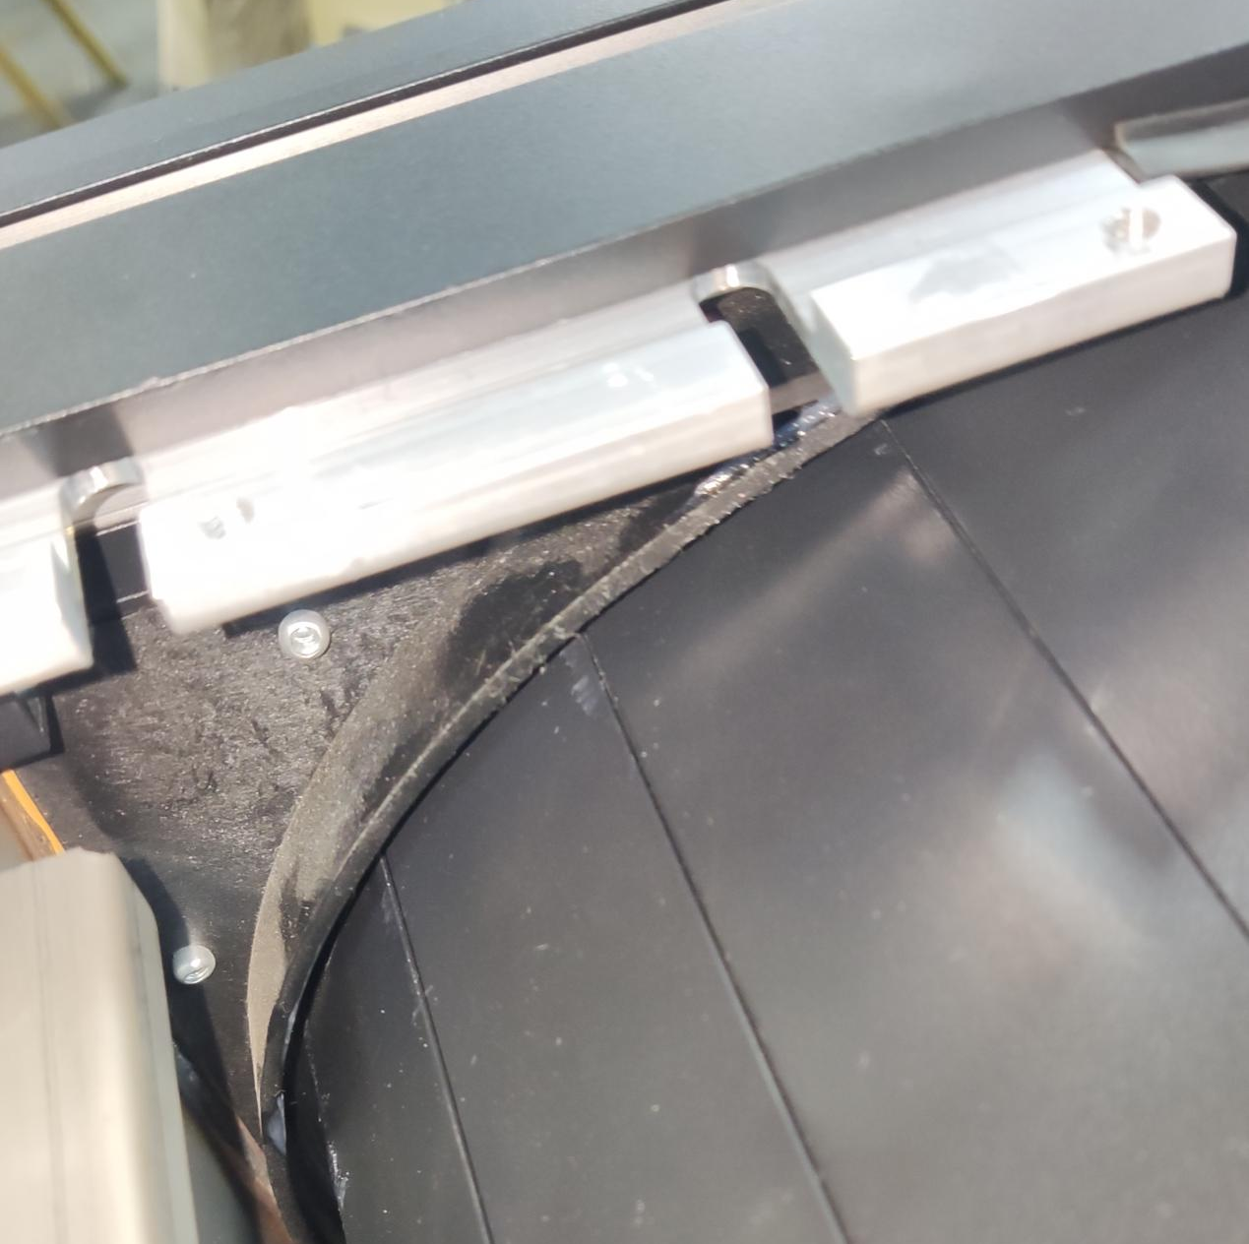
Open the cover plate and apply lubricating grease to this gap

1.Please regularly maintain and lubricate the moving parts and check if all accessories connected to the vehicle are loose to ensure safe use
2.It is not recommended to use electric roller that freeze due to extreme low temperature weather
3.Rainstorm weather or water pipe blockage will lead to untimely drainage of electric roller shutter and water leakage,so it is recommended to park the car indoors in bad weather and regularly check whether the water pipe is blocked
4.When loading goods into the carriage,be careful not to damage the electric roller box

